**Project Title: Software Development Project Management Plan for Dhaka Subway Systems Automated Ticket Issuing System**

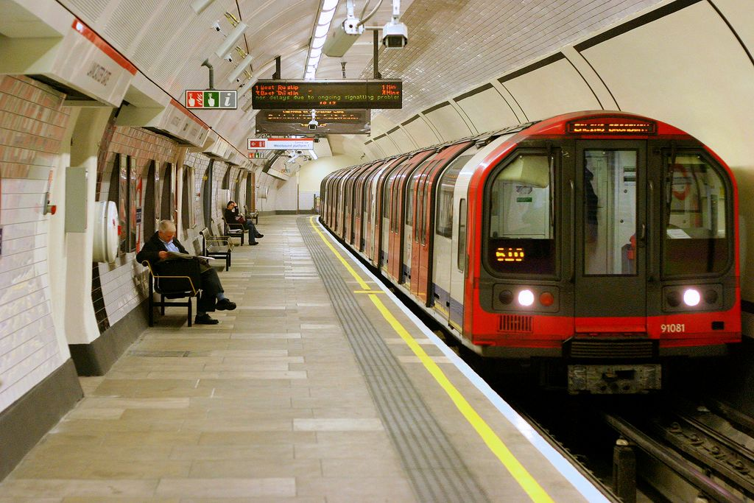

**Course: Software Development Project Management**

**Section: C**

**Submitted By:**

|  |  |
| --- | --- |
| **Name** | **ID** |
| **Hoque, Fahmeda** | **18-36767-1** |
| **Hassan, Abir** | **18-39206-3** |
| **Barua, Susmita Chowdhury** | **18-38541-2** |
| **Sohan, Md Hashinur Rashid** | **18-37482-1** |

**Revision History Page**

|  |  |  |  |
| --- | --- | --- | --- |
| **Revision** | **Authors** | **Description** | **Date** |
| Project Management Plan V.1.0 | Susmita Chowdhury Barua | Initial creation  of the system | 25/06/21 |
| Adding Features Plan V.1.1 | Abir Hassan | Planning for adding features in the system | 04/07/21 |
| Editing Work V.1.2 | Fahmeda Hoque | Formal editorial work | 13/07/21 |
| Revise Features Plan V.2.0 | Rashedul Islam | Revising and minor changes in features plan | 23/07/21 |
| Resource Allocation V.2.1 | Md Hashinur Rashid Sohan | Adding/removing or restoring resources | 31/07/21 |

**Introduction**

This is the software development project management plan for Dhaka Subway Systems Automated Ticket Issuing System. This software project management plan explains in detail the software development lifecycle. This document will include detailed information on the management plan used in this project. The target audience for this project are people in the IT department. It specifies the technical and managerial approaches to the development of software products. All engineering and management activities requiring transfer can be delivered to Dhaka metro system. This includes some factors that can affect the project.

**Process Model**

(a)As we know we have to deliver Software which will produce automated ticket issuing system for Dhaka Subway Systems. And our requirements are clear and specified So we will use waterfall Model.

(b)The waterfall model is break down in some sequential phases. So, in this model we will have some phases and before going to the next phases each phase must be completed. Before completed each phase we have to perform quality assurance test. Even before in every phase the documentation is elaborate. If client in any change they can do it in development process.

(c) The Development Life Cycle for Waterfall Model

Coding/ Implementation

Maintenance

Testing

Design

Analysis

Requirement

**The Following table is showing the list of tasks which are used in Software Development Project**

|  |  |
| --- | --- |
| **Working Product** | **QA Method** |
| Statement Of Work | Inspection |
| SDPM Plane | Inspection |
| Schedule | Inspection |
| SRS | Inspection |
| Design Document | Inspection |
| Code | Run |

**List of tasks (work breakdown structure, WBS)**

## 

|  |  |  |
| --- | --- | --- |
| 10 | 2 | 12 |
|  | **G** |  |
| 8 | 0 | 10 |

|  |  |  |
| --- | --- | --- |
| 0 | 1 | 1 |
|  | **A** |  |
| 3 | 0 | 4 |

## 

|  |  |  |
| --- | --- | --- |
| 0 | 1 | 1 |
|  | **B** |  |
| 0 | 0 | 1 |

|  |  |  |
| --- | --- | --- |
| 1 | 3 | 4 |
|  | **D** |  |
| 1 | 0 | 4 |

|  |  |  |
| --- | --- | --- |
| 4 | 3 | 7 |
|  | **E** |  |
| 4 | 0 | 7 |

|  |  |  |
| --- | --- | --- |
| 7 | 3 | 10 |
|  | **F** |  |
| 7 | 0 | 10 |

|  |  |  |
| --- | --- | --- |
| 0 | 2 | 2 |
|  | **C** |  |
| 2 | 0 | 4 |

|  |  |  |
| --- | --- | --- |
| 15 | 5 | 20 |
|  | **I** |  |
| 15 | 0 | **20** |

|  |  |  |
| --- | --- | --- |
| 10 | 5 | 15 |
|  | **H** |  |
| 10 | 0 | 15 |

Finish

**Estimation (Use the COCOMO81 model)**

COCOMO81 means Constructive Cost Estimation Model which was develop by Dr Berry Boehm in 1981, that’s why it is call COCOMO81. We can evaluate the cost of a software by using this method.

For calculating COCMO81 the basic equation is:

Effort = c × (size)k

Development Time = 2.5 × (effort)t

COCMO81 applies three class of software projects.

* Organic Project
* Semi-Detached Project
* Embedded Project

According to COCOMO, there are three modes of software development projects that depend on complexity.

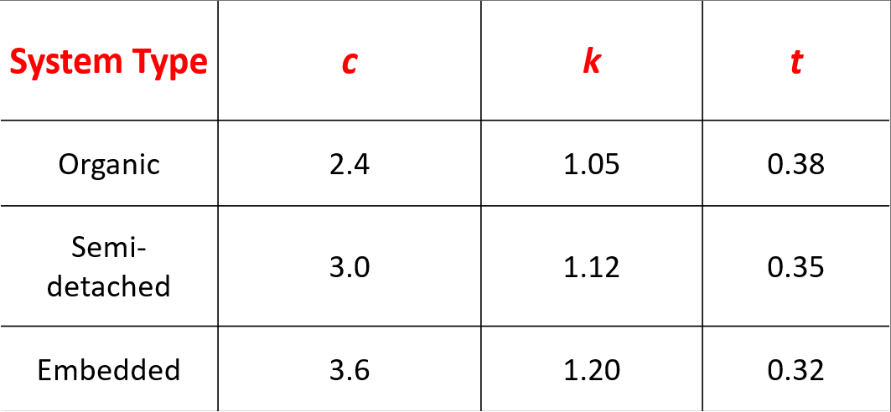

We are assuming that our project will have 500000 lines of code. Now we will calculate the effort and time for the 3 classes of the software project.

Here, LOC = 500000

Therefore, KLOC=500

**Organic:**

Effort = (𝐾𝐿𝑂𝐶) k

= 2.4(500) 1.05

= 1710 person-month

Development time = 2.5(Effort)t

= 2.5(1710) 0.3

= 13 months

**Semi-detached:**

Effort = (𝐾𝐿𝑂𝐶) 𝑘

= 3(500) 1.12

= 3608

Development time = 2.5(Effort) 𝑡

= 2.5(3608) 0.35

= 25 months

**Embedded:**

Effort = (𝐾𝐿𝑂𝐶) 𝑘

= 3.6(500) 1.2

= 8060

Development time = 2.5(Effort) 𝑡

= 2.5(8060) 0.32

= 24 monthd

**Schedule the Tasks**

|  |  |  |
| --- | --- | --- |
| **Tasks** | **Task Duration (Month)** | **Prerequisites** |
| Requirement Elicitation (a) | 1 | n/a |
| Project Agreement (b) | 1 | n/a |
| Requirement Analysis (c) | 2 | n/a |
| Project Planning (d) | 1 | b |
| System Design (e) | 3 | d |
| Object Design (f) | 3 | e |
| Analysis Review (g) | 2 | e,f |
| Implementation and Unit Testing (h) | 5 | e,f |
| System Integration and System Testing (i) | 5 | h |

**Bar Chart:**

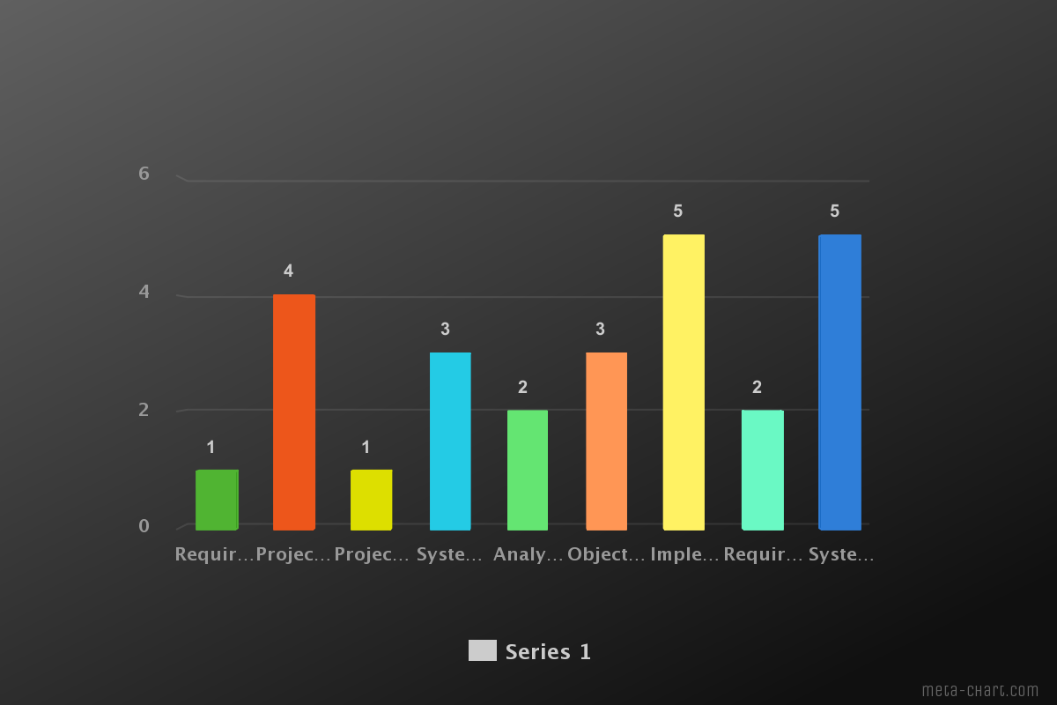

**List of milestones:**

|  |  |  |
| --- | --- | --- |
| NO | Item | Milestone Date |
| 1 | Requirement Analysis and plan the phases | August 10, 2021 |
| 2 | Risk Analysis and backup planes | August 25, 2021 |
| 3 | Design | September 1, 2021 |
| 4 | Coding | September 25, 2021 |
| 5 | Testing/review | December 5, 2021 |
| 6 | Deployment/Publish | January 10, 2022 |

|  |  |  |
| --- | --- | --- |
| NO | Item | Milestone Date |
| 1 | Requirement Analysis and plan the phases | August 10, 2021 |
| 2 | Risk Analysis and backup planes | August 25, 2021 |
| 3 | Design | September 1, 2021 |
| 4 | Coding | September 25, 2021 |
| 5 | Testing/review | December 5, 2021 |
| 6 | Deployment/Publish | January 10, 2022 |

**Staffing Plane**

|  |  |  |
| --- | --- | --- |
| **Person** | **Assignment** | **Back Up** |
| Rasdedul Islam | Project Manager | Fahmida Haque |
| Fahmida Haque | Technical Lead | Susmita Chowdhury |
| Abir Hasan | UX Designer | Arafin Foysal |
| Susmita Chowdhury | Developer | Hashinur Rashid |
| Hashinur Rashid | Data analyst | Rasdedul Islam |
| Arafin Foysal | Tester | Abir Hasan |

**Monitoring and Controlling Mechanism**

The progress of the work is monitored by the project manager. A weekly or biweekly meeting takes place in the manager’s room. Before the meeting, the project manager prepares an agenda for the meeting. Team members can suggest an additional agenda before the meeting. Tasks assigned by the project manager during this meeting. During this meeting, the project manager meets the quality assurance manager. The project manager discusses about the project with the team members. Project Manager make proper planning about the project. A progress report is written by the project manager.

**Risk Management**

**Surveillance:** The features of the project are mostly used with personal information like credit card information, destination, phone numbers, personal details and so on. If any of this information get leaked it will be a great risk for the users. It can be prevented by developing system with high security and only the authorized person can access their own information rather than anyone else.

**Financial Crisis:** Most of the features are required for changing according to client’s requirements. As a result, it seems that the budget of previous planning failed and new budget is need to be created. This cause financial crisis. To prevent this problem an expert can be hired to review the technical plans or the cost estimate on a project to increase the confidence in that plan and reduce the project risk.

**Application and system design:**Developing the wrong software functions, design or architecture can have disastrous consequences. As with the technological risks, it is vital that the team includes experts who understand the architecture and have the capability to make sound design choices.

**Performance:**  It’s important to ensure that any risk management plan bound the user and partner expectations on performance. Consideration must be given to a standard and threshold testing throughout the project to ensure that the work products are moving in the right direction.

**List of deliverables**

|  |  |  |
| --- | --- | --- |
| **Item** | **Description** | **Date** |
| Software Requirement Specification | Software requirements specification or SRS is a document that explain how the system should work. | August 10, 2021 |
| Risk Analysis | Risk analysis is a method for find out the risks in software. | August 15, 2021 |
| Software Development Project Management Plan | Software development project management plan is mainly a project timetable. It provides the start and finish dates for each phase of software project. | August 20, 2021 |
| Software Test Plan | Software test plan is a report that specifies the actions of software testing. | August 25, 2021 |
| Software Quality Assurance Plan | Software Quality Assurance Plan describes the tools used to ensure that a product meets the standards specified in the software requirements specification. | October 1, 2021 |
| Software Verification | Verification is the process of examining the program to determine whether or not the software meets the requirements. | October 12-15, 2021 |

**Defect Tracking Process**

Defect Tracking process is basically the bug tracking process. To detect bugs, we have many tools. But in this project, we will use JIRA SOFTWARE. This software is a bug tacking tool as well as a project management tool. We can also find, record and track bugs. It has also a system which assign the right person to the right time.

Jira is quite popular among the developers. Industries are using this widely, because there methodologies interfaces attract the developer and testers, and quite simple to use. It is highly customizable; it is for different type of users.

As other software JIRA also has some cons like Agile method is suitable for this software as It support the Agile method perfectly. So, for it will be little bit confuse as we are using Waterfall Model. It has a confusing UI, Limited file size upload, even complex migrations.

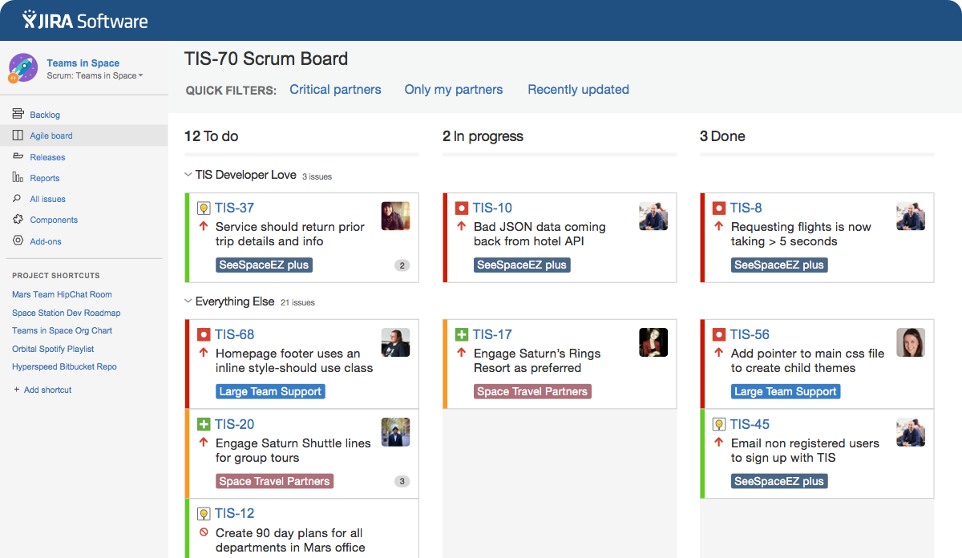

**List of matrices:**

* Cost Matrix
* Quality Matrix
* Time Matrix
* Code
* Test Matrix
* Developer Productivity

**Post-Mortem**

The overall project plan follows the waterfall model. 3 prototypes will be delivered: A graphical user interface, a functional prototype and a system integration prototype. Analysis will be start started before Project Planning. System Design is followed by the Object Design. Implementation and Unit Testing both are schedule to overlap significantly. System Integration is schedule to the follow Unit Testing. System Testing will be start immediately after system integration. We hope that the project will be completed in the right time.